|  |  |
| --- | --- |
| **Server & Cloud Security**  Diploma in CSF/IT  Oct 2022 | Week 2 |
| Practical |
| **Practical: Configure HTTP Web Service** | |

**1. Introduction**

A static website is to be built on the IIS server. Static content is a web page (HTML) that is delivered to the user exactly as stored. By contrast, dynamic content is generated by a web application, such as an ASP.NET, classic ASP, or PHP application. Static content displays the same information for all users; dynamic content can display user-specific information, such as the user name.

**2. Detailed Requirements**

**Task #1: Website Parameters Configuration**

On MS1 server, open **Server Manager**, click the Tools menu, and then click **Internet Information Services (IIS) Manager**. On the Connections pane, right-click the **Sites** node in the tree, and then click **Add Website**.

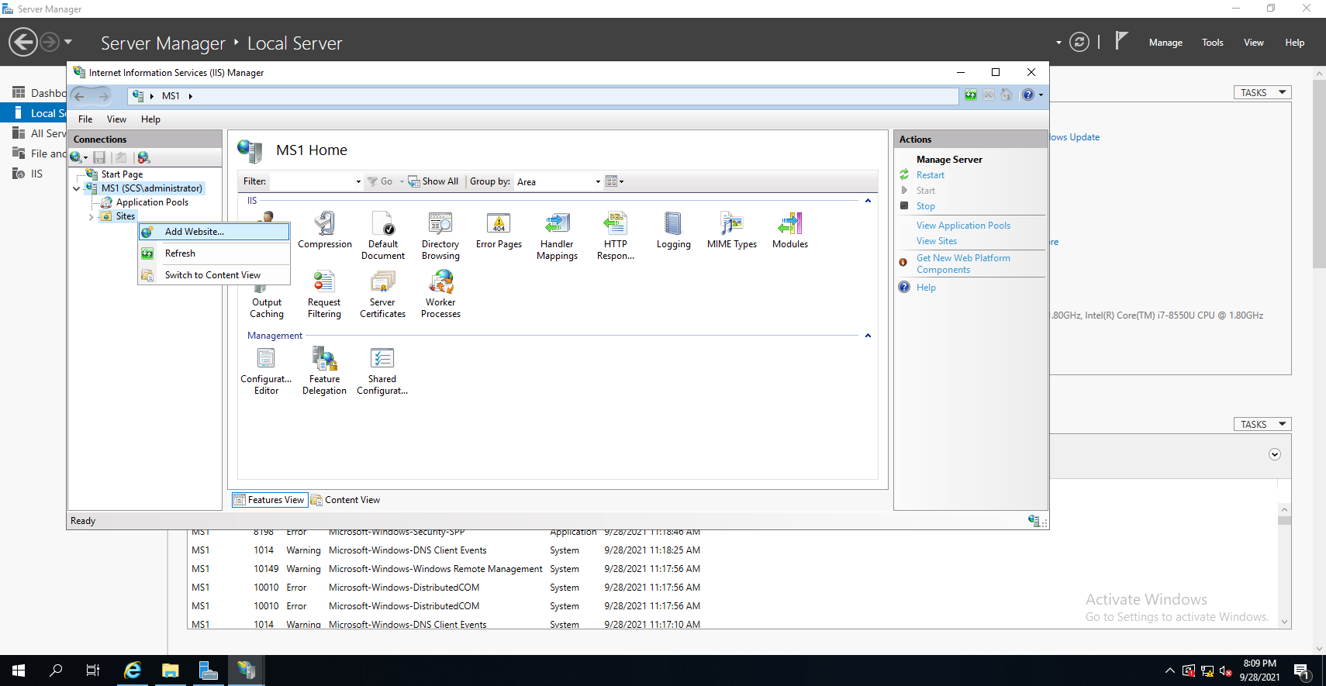

When assigning the Physical Path of the website, **choose a D:\ or E:\ drive other than C:\ to ensure full access right. If your VM does not have a second partition, learn to create it.**

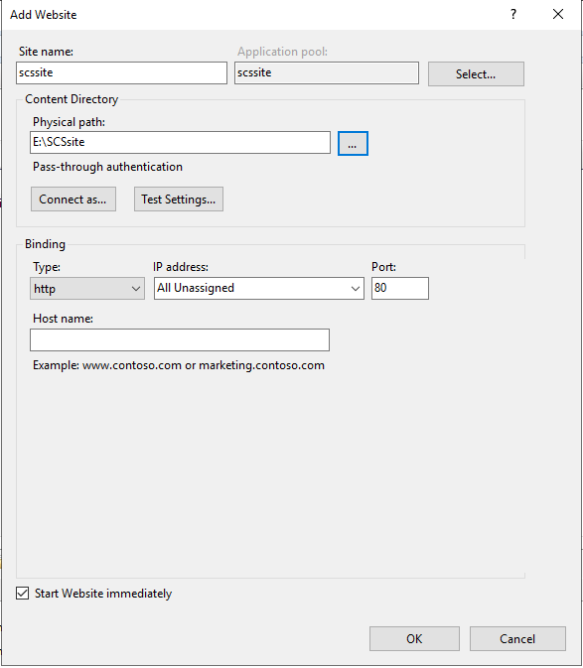

**Define your own**

**site name**

Leave the “IP Address” and “Host Name” blank at this stage.

**Task #2: Write a Simple Webpage**

Create a txt file in the folder you created in Task 1 Physical Path.

You may right click the site you just created and select **Explore**. This will lead you to the directory of the website’s folder.

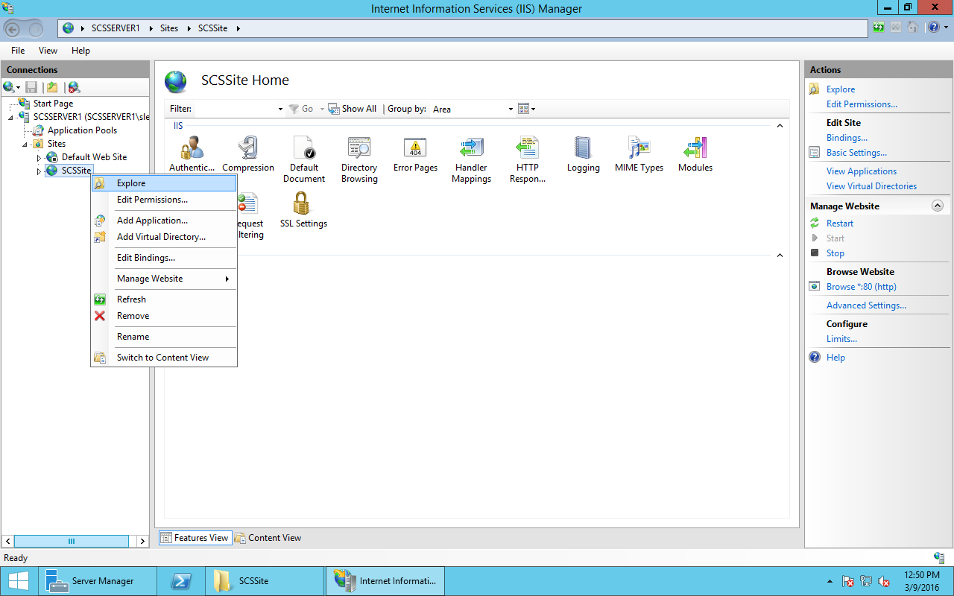

Copy and paste the below text into the file and save it as “main.html” format. Take note of the file name and extension.

<!DOCTYPE html>

<html>

<body>

<h1>Server & Cloud Security </h1>

<p>Testing Site</p>

</body>

</html>

Double click the **Default** **Document** in the website home pane.

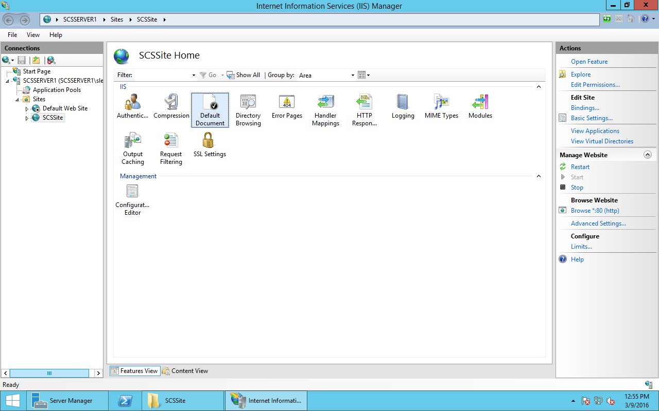

Then click **Add** in the Actions pane and add the HTML file you just created, and ensure the file is moved to the top of the list.

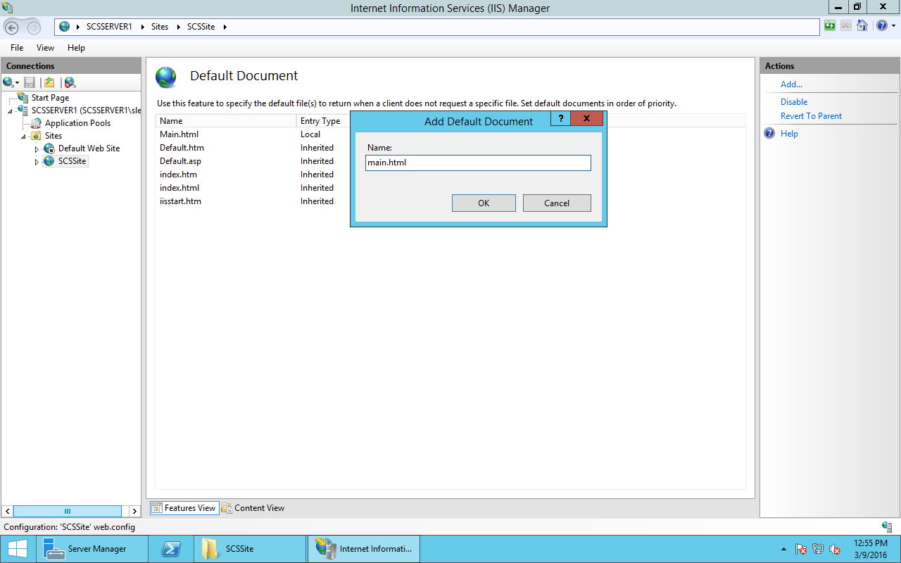

Test the browsing of website and ensure your webpage is displayed correctly similar to the below screenshot.

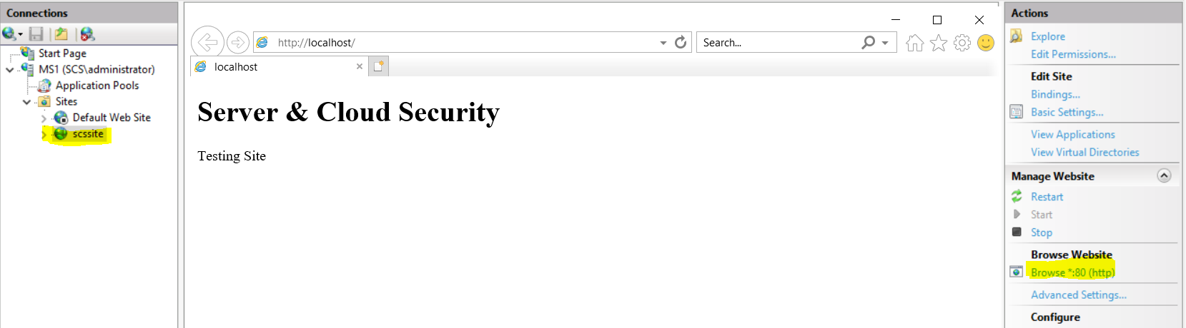

**Task #3: Access the Website from a Remote Machine**

Edit your site binding to include IP address.

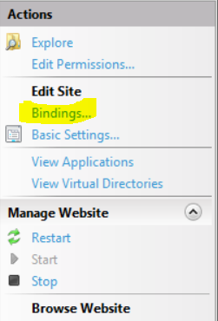

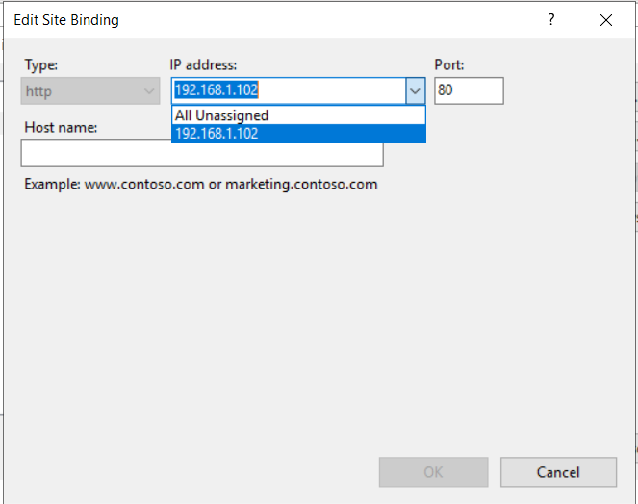

Make sure you can access your website from DC1’s browser.

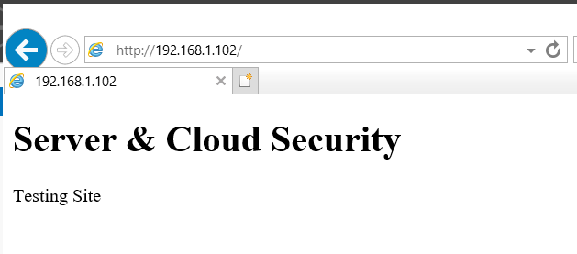

**Remarks:**

If you encounter the below error message, you can edit the “IE Enhanced Security Configuration” setting to turn it OFF.

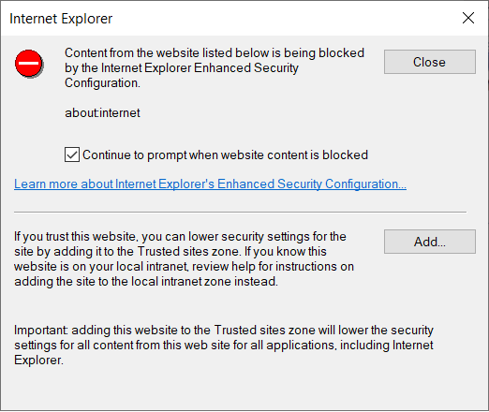

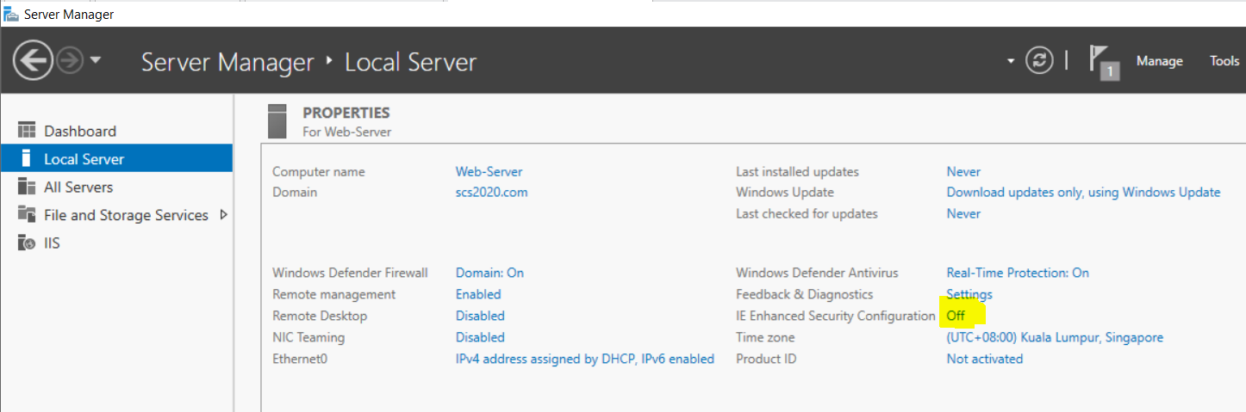

**Task #4: Edit the Website with a Host Name**

Edit the binding again to include a Host name (URL) as shown below. Now you cannot open your webpage even from the web server itself.

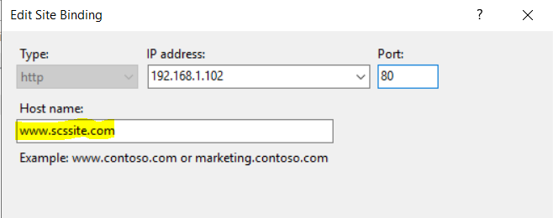

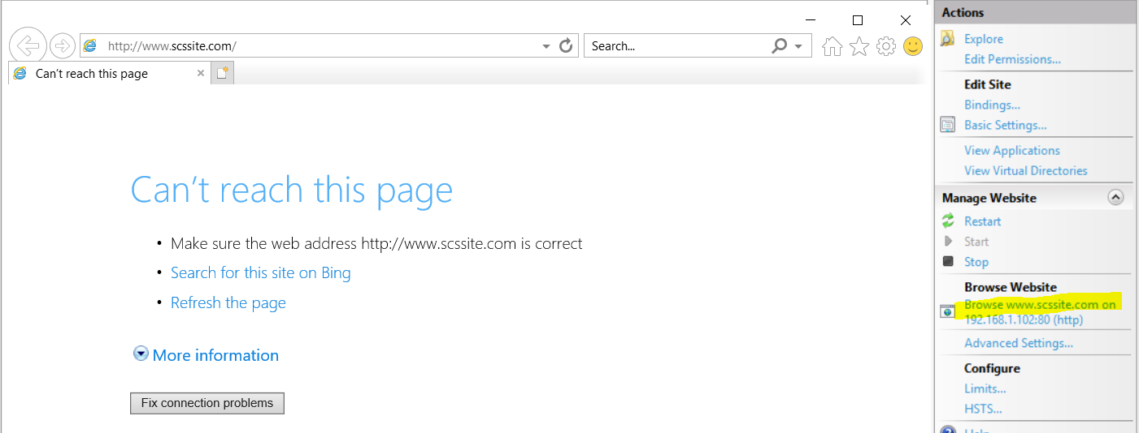

Question: What is the cause of this problem and how can you solve it?

|  |
| --- |
| The host name has not been linked to an IP address on the DNS server.  Without this linkage there is no IP address to connect to after the host name is queried. |

**Task #5: DNS Configurations**

**Method 1:**

Open DNS tool from your domain controller - **DC1** server, Server Manager🡺Tools🡺DNS.

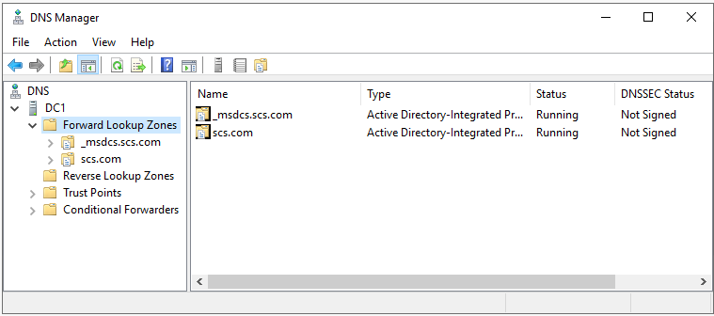

As shown above, by default you can see your domain appears inside the Forward Lookup Zones. **DO NOT** touch your domain and **Don’t** confuse it with your website URL.

Right click “Forward Lookup Zones” and choose “New Zone” with Zone type as “Primary zone”. Click Next for all the default settings until Zone Name. Put your website name as the zone name and click next then finish.

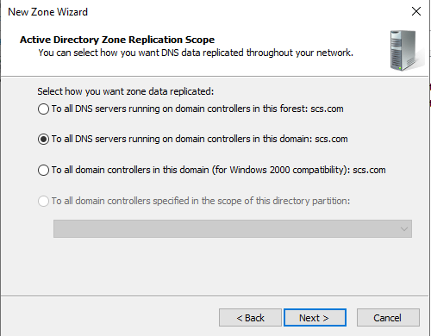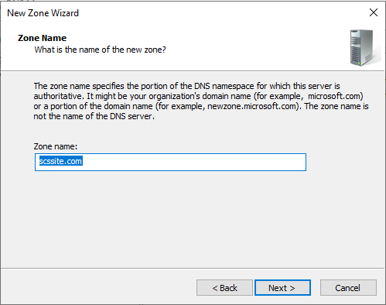

Now you should be able to see both your domain and your website under the Forward Lookup Zones similar to the screenshots below. Right click your newly created zone and choose “New Host”. Follow the below screenshots to create your new host and then click “Add Host”.

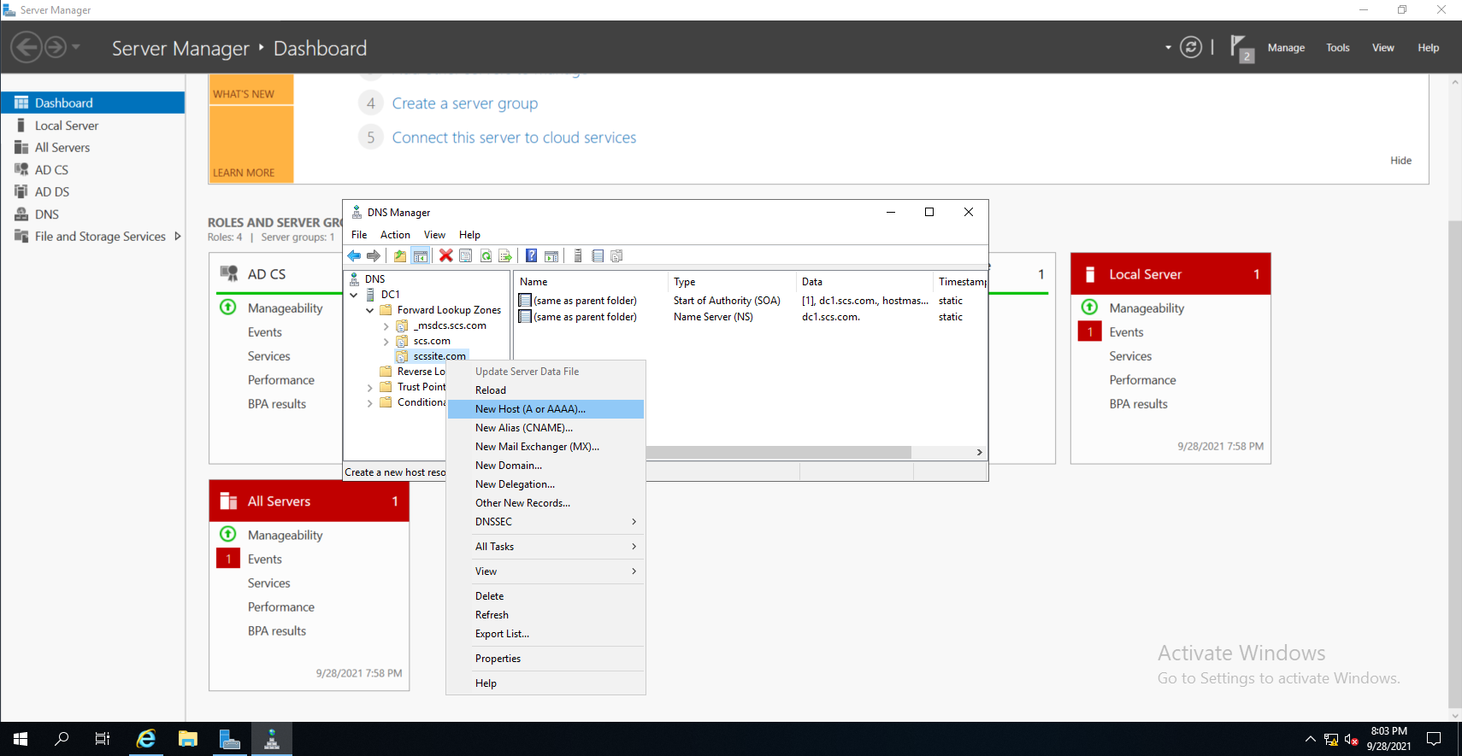

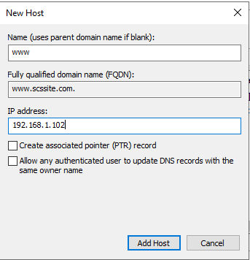

**Your MS1 Server’s IP Address**

Your host now is successfully added and you can test the connection of it from your DC1 server.

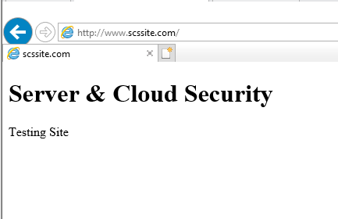

**Method 2 (Optional):**

Instead of modifying the DNS configurations on your domain controller (DC1), you may also complete the below tasks directly on the web server (MS1):

Access the “hosts” file from the below path and edit it to include the IP address and host name of the website.

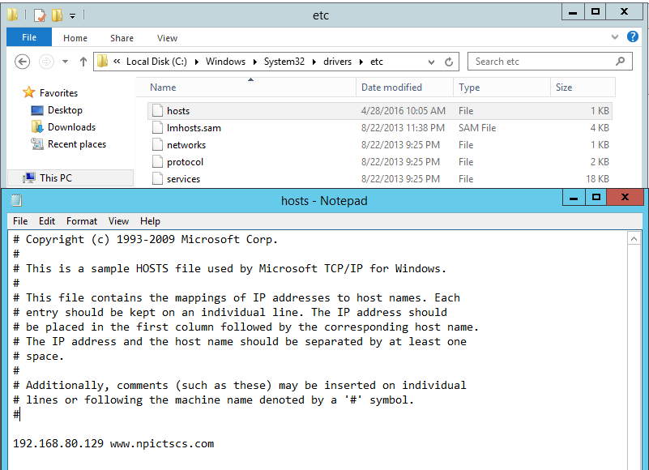

**Your MS1 Server’s IP Address & URL**

- The End -